Financial summary
The FRC is a statutory body under the Family Responsibilities Act 2008 and for the purposes of the:
- Financial Accountability Act 2009
- Financial and Performance Management Standard 2019
- Statutory Bodies Financial Arrangements Act 1982.
This summary provides an overview of the FRC’s financial performance for 2022-23 and a comparison to 2021-22. A comprehensive set of 2022-23 financial statements covering all aspects of the Commission’s activities commences on page 78.

Our overall performance
Table 10: Summary of financial performance
Summary statement | 30 Jun 2023 | 30 Jun 2022
 | $000 | $000
Income | 4,450 | 4,245
Less: expenses | 4,299 | 3,964
Operating surplus | 151 | 281

Income
Table 11: Summary of income by type
Income by type | 30 Jun 2023 | 30 Jun 2022
 | $000 | $000
State Government funding | 2,489 | 2,418
Australian Government funding | 1,800 | 1,800
Interest income | 160 | 25
Other income | 1 | 2
Total | 4,450 | 4,245

The increase in State Government funding is the application of a CPI increase. Interest income earned on cash at bank balance increased year on year by $135K due to higher interest rates in 2022-23.

Expenses
Table 12: Summary of expenses by type
Expenses by type | 30 Jun 2023 | 30 Jun 2022
 | $000 | $000
Employee expenses | 3,063 | 2,967
Supplies and services | 1,129 | 910
Depreciation and amortisation | 53 | 40
Finance/borrowing costs | 7 | 3
Other expenses | 47 | 44
Total | 4,299 | 3,964

Employee expenses represented 71 percent of the total expenditure in 2022-23 compared to 75 percent in 2021-22 even though there was an increase in employee expenses from $2,967,000 in 2021-22 to $3,063,000 in 2022-23 (an increase of 3 percent from the prior year). This is attributable to the appointment of an IT Support officer as well as a wage increase applied in September 2022. Offsetting the cost were vacancies in the second half of the year and savings made on payroll tax due to the Commission no longer being a grouped entity for payroll tax purposes.
Increase in supplies and services relates to engaging temporary employment services to fill vacancies throughout the year, such as an ICT Administrator and an Executive Officer (Corporate). The Commission’s property costs have increased due to the Department of Energy and Public Works, who manage the Aurukun staff accommodation, starting to charge rent in the 2022-23 financial year.
The expenditure of the FRC can be categorised as follows:
- Community operations – further broken down into:
  - On-the-ground community operational expenses including the operational expenses in each of the five communities to conduct conferences and hearings, prepare and monitor case plans for clients for attendance at community support services and prepare and monitor income management orders and agreements.
- Support and facilitation expenses including costs associated with facilitating the holding of conferences and hearings in the five communities, providing support to the Local Commissioners and Local Registry Coordinators to hold conferences and hearings, assisting with the on-going monitoring of case plans for clients through the provision of data and other information and processing income management orders and agreements.
- Corporate governance includes finance, statistical reporting, corporate governance, compliance, training and other administrative functions to ensure the effective and efficient operations of the Commission.

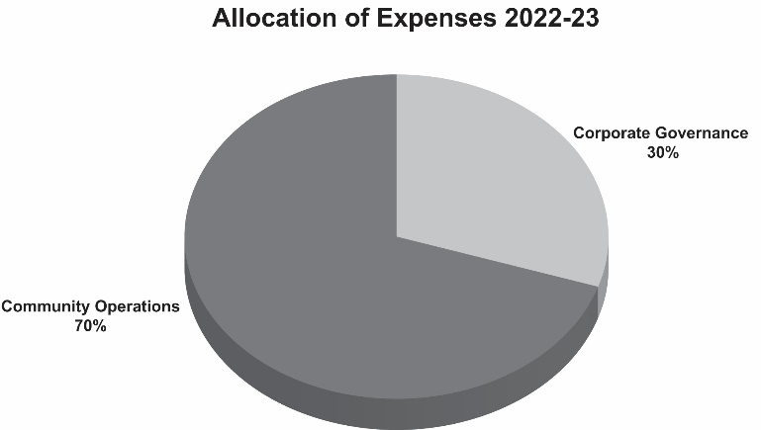
The allocation of the FRC’s costs in 2022-23 based on the above was:

Graph 12: Allocation of expenses
1 July 2022 to 30 June 2023
These FRC expenses can be further categorised as front-line and non-frontline in accordance with the Queensland Public Service Commission definitions.
Community operations and conference facilitation expense are frontline expenses and are conducted on-the-ground in community by Local Registry Coordinators and Local Commissioners, and in the Cairns registry office to support the holding of FRC conferences and hearings across the five communities.
The Local Commissioners are paid sessional fees per Level 3 Adjudication and determination in accordance with the Remuneration Procedures for Part-Time Chairs and Members of Queensland Government Bodies. When engaged, the Local Commissioners could be holding conferences and/or hearings, serving notices, attending meetings or undertaking professional development.
The work undertaken by the CM&M team in the Cairns registry includes duties which are undertaken to support conference prioritisation and scheduling and preparation of client records for consideration by the Local Commissioners, processing decisions made and preparing and monitoring case plans and/or income management orders and agreements. This work is essential to support the Local Commissioners when conferencing which is central to the FRC’s role and could not be efficiently or easily undertaken in the communities themselves.
For 2022-23 70 percent of FRC expenses were utilised to support frontline operations, whilst 30 percent supported corporate governance.

Our position
Total assets as at 30 June 2023 consisted of current assets of cash, prepayments and receivables in addition to non-current right-of-use assets.
Total liabilities as at 30 June 2023 consisted of payables, accrued employee benefits and lease liabilities.
Table 13: Statement of financial position
Statement of financial position | 30 Jun 2023 | 30 Jun 2022
 | $000 | $000
Total assets | 4,026 | 3,960
Total liabilities | 346 | 431
Net assets | 3,680 | 3,529
Total equity | 3,680 | 3,529

